2.CASSANDRA CRUD OPERATION
AIM:
To perform CRUD operation using Cassandra shell.

QUERIES:
1.CREATE KEYSPACES:
cqlsh> CREATE KEYSPACE viims1 WITH replication={'class':'SimpleStrategy','replication_factor':2};

2.DESCRIBE KEYSPACES:
cqlsh> describe keyspaces;

3.USE KEYSPACE:
cqlsh> use viims1;

4.CREATE TABLES IN KEYSPACE:
cqlsh:viims1> CREATE TABLE student(sno int PRIMARY KEY,sname text,dept text,mobile int);

5.INSERT MULTIPLE VALUES INTO TABLE:
cqlsh:viims1> insert into student(sno,dept,mobile,sname)values(1,'mca',23232,'abi');
cqlsh:viims1> insert into student(sno,dept,mobile,sname)values(1,'mca',23232,'akila');

cqlsh:viims1> insert into student(sno,dept,mobile,sname)values(2,'mca',232452,'preethi');
cqlsh:viims1> insert into student(sno,dept,mobile,sname)values(3,'mca',452452,'hemalatha');
cqlsh:viims1> insert into student(sno,dept,mobile,sname)values(4,'mca',152452,'ishwarya');
cqlsh:viims1> insert into student(sno,dept,mobile,sname)values(5,'mca',572452,'akshaya');

6.DISPLAY THE RECORDS IN TABLE:
cqlsh:viims1> select * from student;

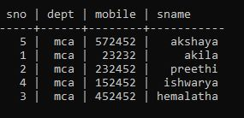
(5 rows)

7.UPDATE VALUES IN THE TABLE:
cqlsh:viims1> update student set mobile=93456,dept='mba' where sno=1;
cqlsh:viims1> select * from student;

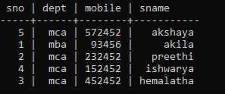
(5 rows)

8.UPDATE MULTIPLE VALUES INTO TABLE:
cqlsh:viims1> update student set mobile=92356,dept='mba' where sno=3;
cqlsh:viims1> select * from student;

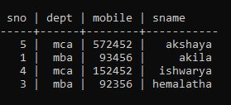
(4 rows)

cqlsh:viims1> update student set sname='sri',dept='mba' where sno=1;
cqlsh:viims1> select * from student;

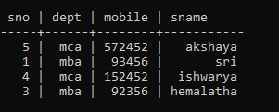
(4 rows)

9.DELETE VALUES FROM THE TABLE:
cqlsh:viims1> delete from student where sno=2;
cqlsh:viims1> select * from student;

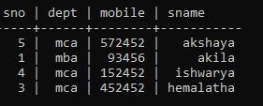
(4 rows)

10.CREATINGT USER DEFINED DATA TYPE:
cqlsh:viims1> create type if not exists viims1.myaddress(street text,doorno text,pincode text);
cqlsh:viims1> create table person(pid int primary key,pname text,address list<FROZEN<myaddress>>);
cqlsh:viims1> insert into person(pid,pname,address)values(1,'srimathi',[{street:'vivekanandha street',doorno:'F23 staffquarters',pincode:'625307'}]);

cqlsh:viims1> select * from person;

(1 rows)

11.SHOW VALUES IN TABLE:
cqlsh:viims1> select * from student;
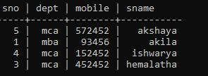
(4 rows)

RESULT:
Thus the above program has been executed successfully.

